BUSINESS REPORTING TOOLS

ASSIGNMENT

ON



**SUBMITTED BY** -

Prineet Kaur Bhurji

**INDEX** –

1. **Executive Summary** (Understanding and Preparing the data)
2. **Dashboards**
   * *Dashboard 1:* Delay Percentages
   * *Dashboard 2:* Impact of weather on the delay
     1. By Humidity, Dew Point and Temp
     2. By Precipitation, Pressure and Wind Speed
   * *Dashboard 3:* Origin vs Destination
   * *Dashboard 4:* Best vs Worst Airlines
   * *Dashboard 5:* Delays by Plane Types
3. **Inferences and Conclusions**

**Executive Summary**

Through this project we explored a specific Dataset (NYC Flights - 20200923) of Domestic Flights that departed from the three major New York City airports in 2013. Using Tableau software, we generated simple graphical and numerical summaries of data on these flights and explored the delay times.

*Flights Summary (As per Origin, Months and Top Destinations)*

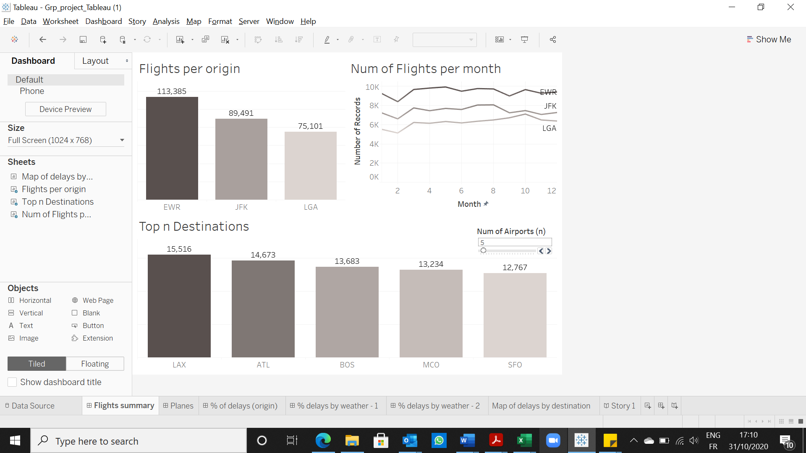

This dashboard uses the “Flights per origin” chart as a filter so that the other charts can be regulated to see results for a particular origin. The top n destinations chart uses an interactive slider to control how many destinations the user wants to see.

*Planes Summary*

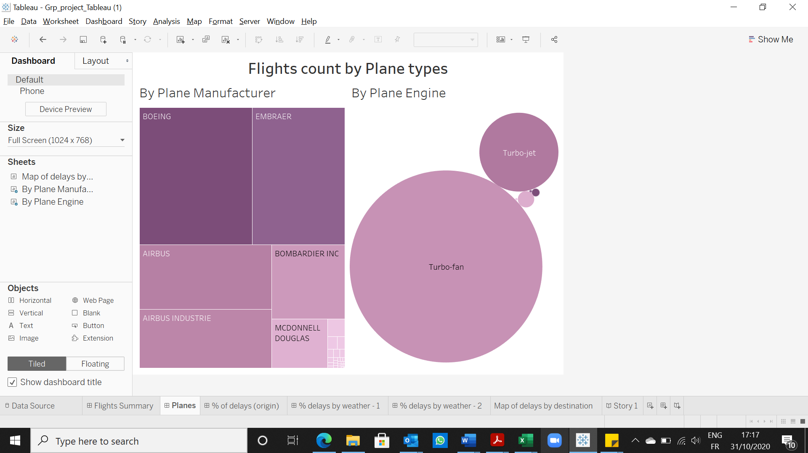**Dashboards**

***Dashboard 1:*** *Delay Percentages*

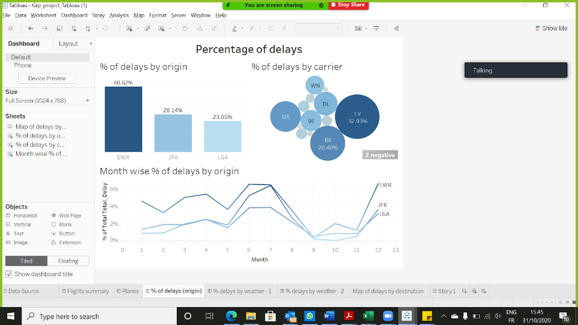

***Chart1:*** % of delays by origin

EWR: 48.79%

JFK : 28.08%

LGA : 23.12%

We can observe that EWR has some connections with maximum delays; it may be due to any reason, like maintenance issues or maybe the weather is worst in that location

***Chart2:*** Percentage of delays by carrier

EV which is express Jet Airlines Inc is 32.95%, Skywest Airlines Inc is 0.01% followed by MG which is Envoy Air 0.28%

We can say that may be EV was facing internal issues in 2013 thus involved maximum delayed whereas Skywest Airlines have offered least delays.

***Chart3:*** Percentage of delays by origin / month wise

For all airports, highest delays were seen from March to August. Then we have a major drop in month September, where it reaches the lowest point. The highest delays were seen during June and July.

***Dashboard 2:*** *Percentage delays by Weather*

1. *As per Humidity, Dew Point and Temperature*

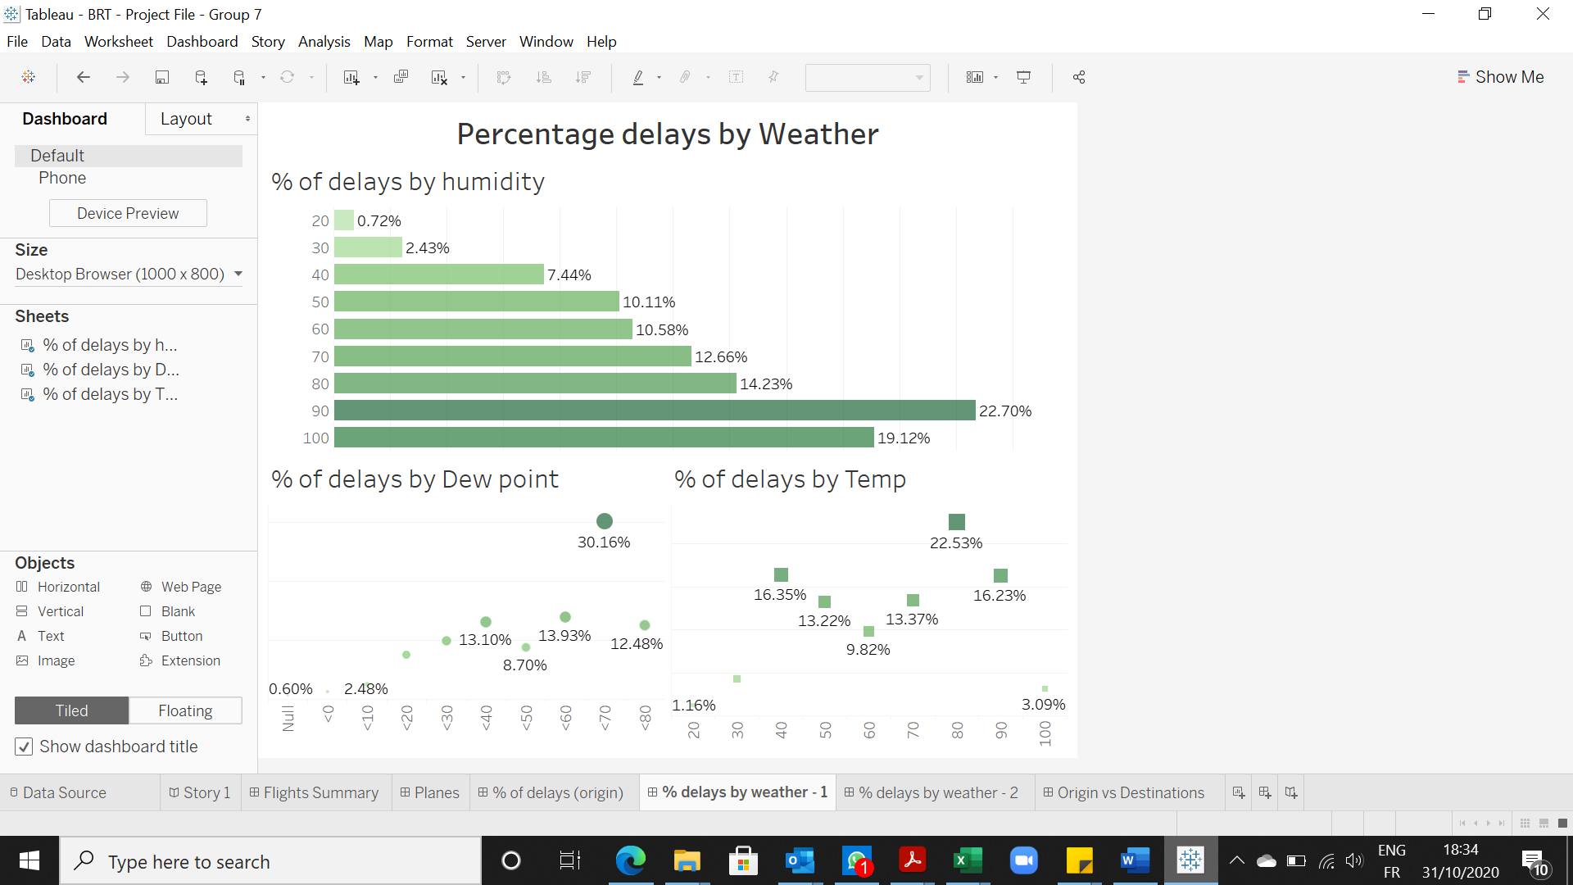

***Chart1:*** % of delays by Humidity

The highest when humidity level is high when it is uncomfortably humid and lowest is when humidity level is low when it is dry.

***Chart2:*** % of delays by Dew Point

The highest when dew point level is greater than 70 when it is oppressive and lowest is when dew point level is low when it is pleasant. And this is because a high dew point means a higher density altitude, which reduces aircraft performance.

***Chart3:*** % of delays by Temperature

The highest delays are seen when the temperature levels are seen between 70-90 °F and lowest delays are seen when the temperature is less than 30°F.

The reason for this can be that as temperature increases, and humidity increases, the air becomes less dense, and therefore the air creates less lift for the airplane.

1. *As per Precipitation, Pressure and Speed*

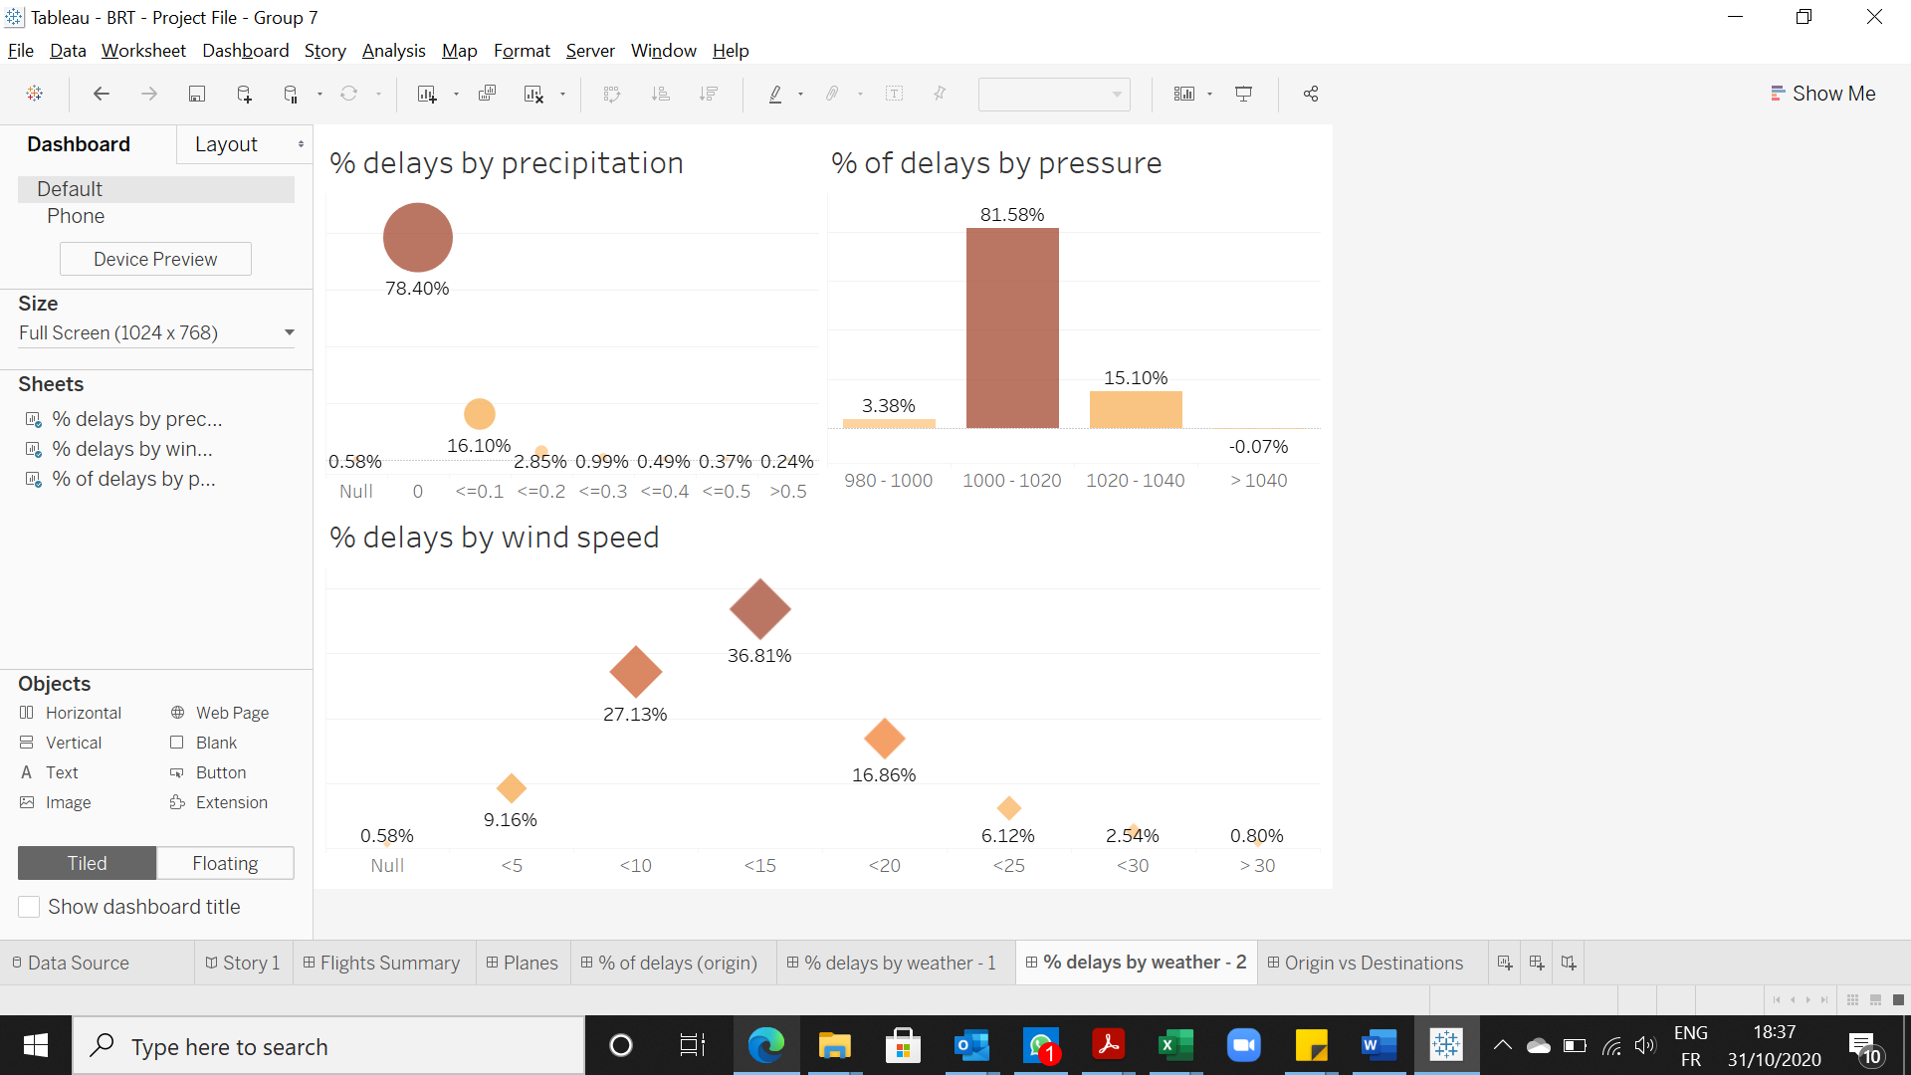

***Chart1:*** % of delays by Precipitation

We can observe that the maximum delays were seen under circumstances when the precipitation was Zero. This shows that rains don’t affect the delays.

***Chart2:*** % of delays by Pressure

When air moves faster, the pressure of the air decreases. So, the pressure on the top of the wing is less than the pressure on the bottom of the wing. The difference in pressure creates a force on the wing that lifts the wing up into the air.

***Chart3:*** % of delays by Wind Speed

We can see that the delays are highest when the wind speed is between 10 to 20 mph and the least is when the wind speed is greater than 30mph.

***Dashboard 3:*** *Origin vs Destination*

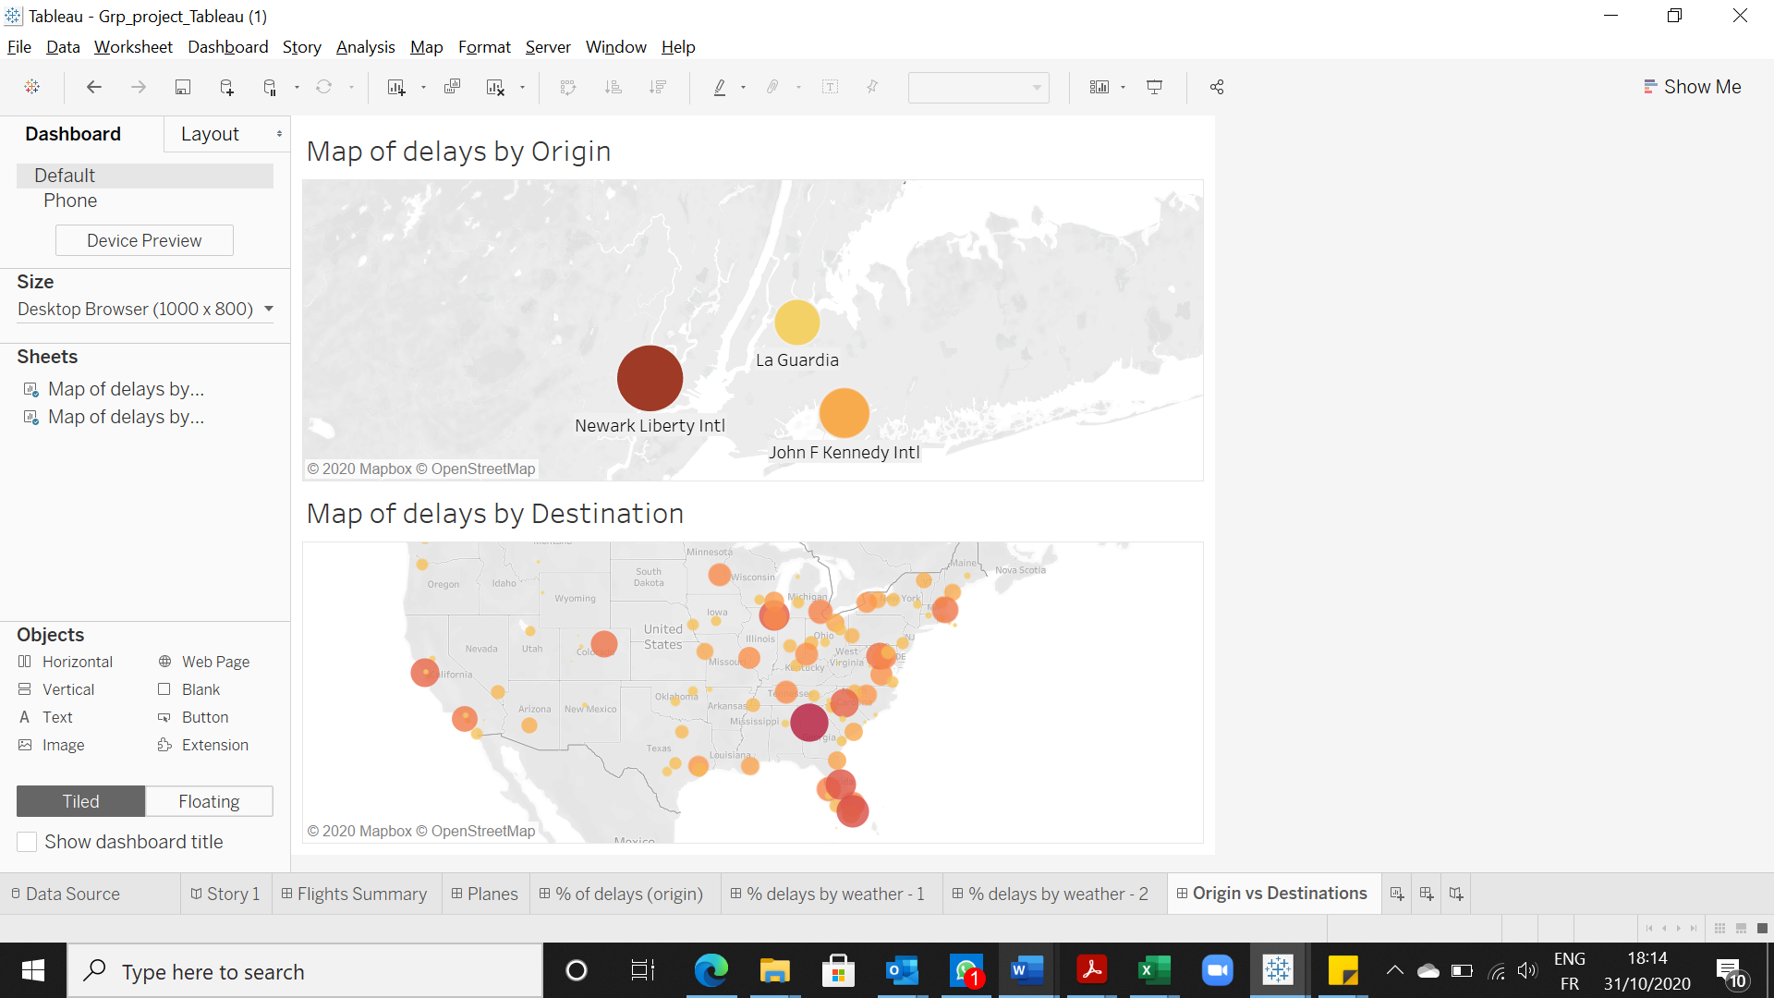

We can observe from the above Charts that the maximum delays for Origin occurred for Newark Liberty Intl airport and for Destination it was for Hartsfield-Jackson Atlanta Intl Airport.

***Dashboard 4:*** *Best vs Worst Airlines*

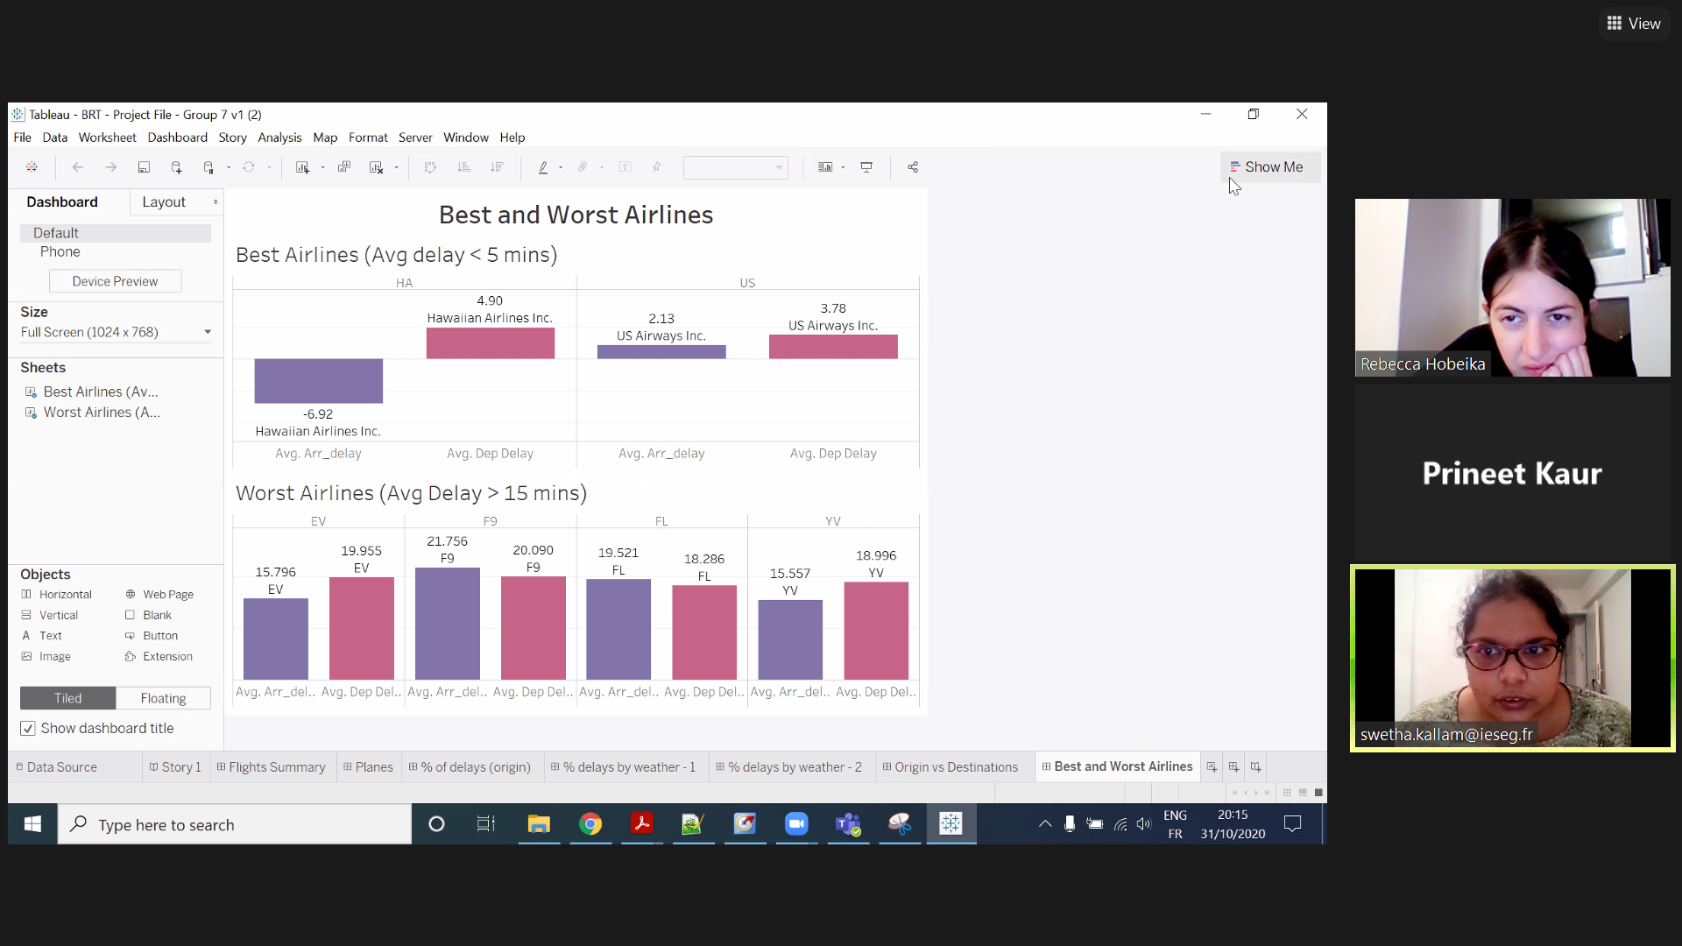

We can observe that the best airlines with average arrival and departure delays less than 5 minutes are Hawaiian Airlines and US Airways. And the worst airlines with average delays greater than 15 minutes are ExpressJet, Frontier, Airtran Airways corporation and Mesa Airlines.

***Dashboard 5:*** *Delays by Plane Types*

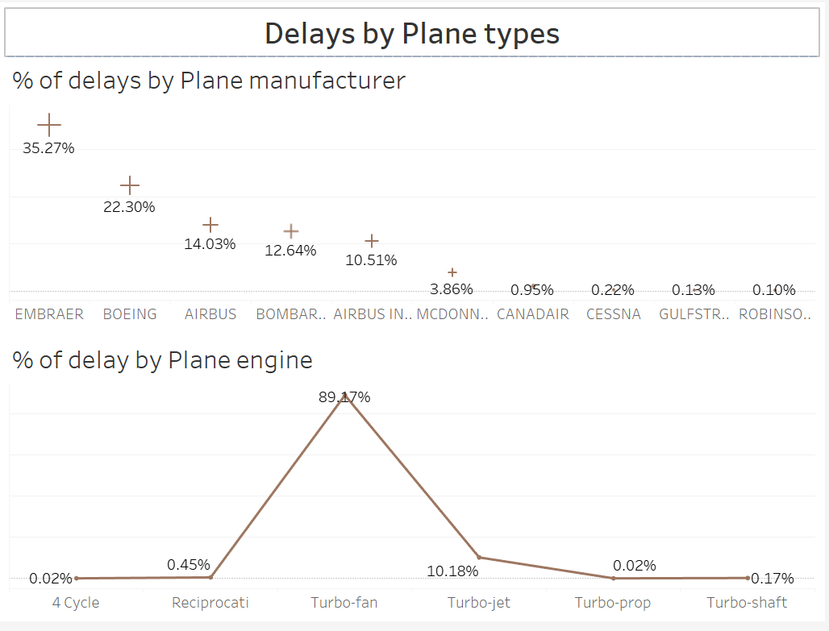

***Chart1:*** % of delays by Plane Manufacturer

The above illustration shows that the maximum delay was seen for flights that were manufactured by Embraer and Boeing. This is also because of the reason that they are manufacturing maximum number of airplanes and thus contributing more to the delays.

***Chart2:*** % of delays by Plane Engine

We can say that its either that most of the planes are having Turbo-Fan and thus they add maximum to the over all delay statistics or else its something related to Turbo-fan engines that cause more delay.

**Inferences and Conclusions**

Overall, this data set allowed us to create multiple graphs, dashboards and a story analysing the flights leaving New York in 2013. Our Tableau analysis lets us understand various reasons for flight delays considering different criteria such as distance, weather, time of the day, airport, airline and so on. To conclude, there are different reasons why flights face delays, but with our data we have an idea when these delays can happen. This could allow us to predict potential delays and deal with them in the best possible way. Indeed, we can see that different periods of the year or of the day have higher delays than others. Therefore, for these periods maybe more planes could be made available to reduce the cumulative delay. Moreover, weather is a key external factor of delay. It is harder to predict the exact weather, but we can have some predictions which could allow the adaptation of flight schedules. Our analysis could therefore bring some predictions and help NY airports limit their flight delays.